Zepto Inventory & Product Analysis
SQL Data Exploration, Cleaning and Business-Oriented Analysis
Project Type: Exploratory SQL Data Analysis
Database: MySQL 8.0
Tool: MySQL Workbench
Dataset: Zepto product and inventory dataset
Analyst: Pritam Kundu

1. Project Overview
The objective of this project was to explore a Zepto product and inventory dataset using SQL, perform basic data cleaning, and investigate product pricing, discounts, stock availability and category-level inventory patterns.
The project follows a typical analytical workflow:
- Database and table creation
- Data import and exploration
- Data quality checks
- Data cleaning and transformation
- SQL-based analysis
- Interpretation of findings and limitations
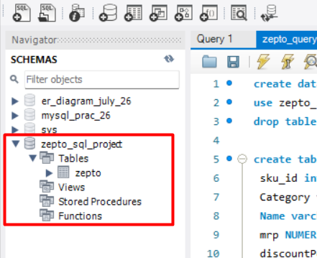
2. Dataset Overview
The dataset contains product-level information, including:
Column | Description
sku_id | Product record identifier generated during import
Category | Product category
Name | Product name
mrp | Maximum Retail Price
discountPercent | Listed discount percentage
availableQuantity | Available inventory quantity
discountedSellingPrice | Selling price after discount
weightGrams | Product weight in grams
outOfStock | Stock availability indicator
quantity | Product quantity information
Each record represents a product SKU. Repeated product names do not necessarily mean duplicate records because different package sizes or variants can exist.
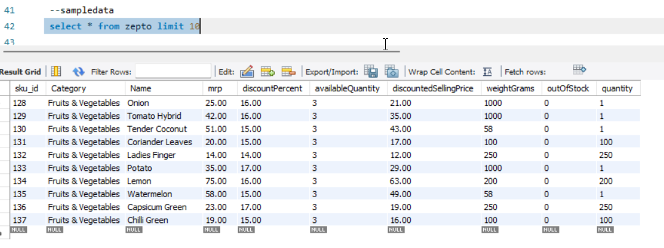
3. Database Creation and Data Import
Created a MySQL database named zepto_sql_project and a table named zepto.
Used appropriate SQL data types, including:
- INTEGER for identifiers and quantities
- VARCHAR for product names and categories
- NUMERIC for prices and discounts
- BOOLEAN for stock availability
Imported the CSV dataset using MySQL's LOAD DATA INFILE statement.
Why this step matters: A structured database allows the dataset to be queried, filtered, grouped and analysed efficiently.
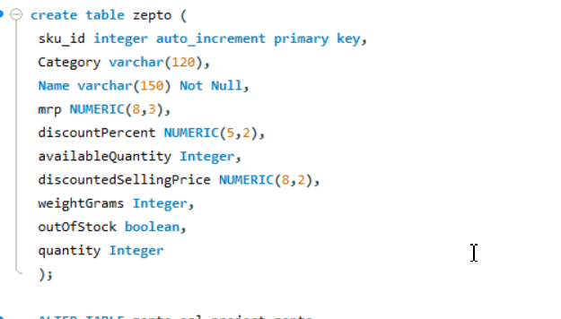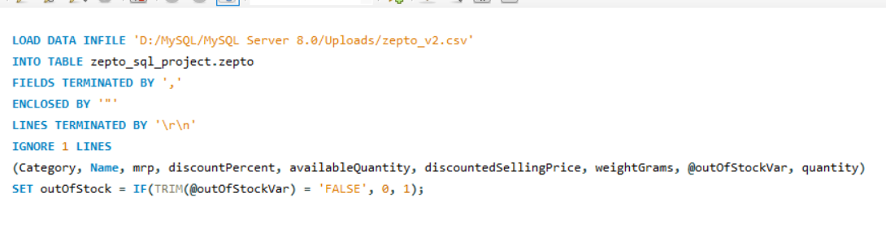

4. Data Exploration
Before cleaning, I explored the dataset to understand its structure and quality.
The following checks were performed:
- Retrieved the total number of records using COUNT(*).
- Examined sample records using LIMIT.
- Checked for NULL values across important columns.
- Identified distinct product categories.
- Compared in-stock and out-of-stock product counts.
- Investigated repeated product names using GROUP BY and HAVING.
Why these checks matter:
They help identify missing information, understand the dataset's structure and detect patterns that may affect later calculations.
Repeated product names were investigated rather than automatically deleted because different SKUs can represent different product variants.
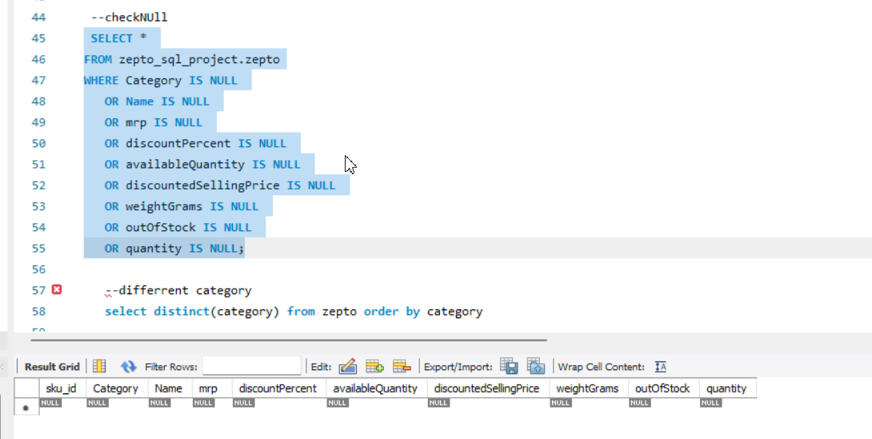
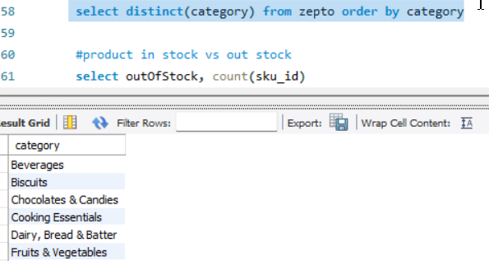
5. Data Cleaning and Transformation
The following operations were performed:
5.1 Identifying zero-price records
Used conditions on MRP and discounted selling price to identify records containing zero values.
Records with zero MRP were removed from the analysis table.
5.2 Price conversion
Converted MRP and discounted selling price from paise to rupees by dividing the values by 100, based on the source dataset's price units.
5.3 Data preparation
Checked the cleaned price values and prepared the dataset for subsequent calculations.
Why these steps matter:
Invalid or inconsistent price values can distort average prices, price comparisons and inventory valuation calculations.
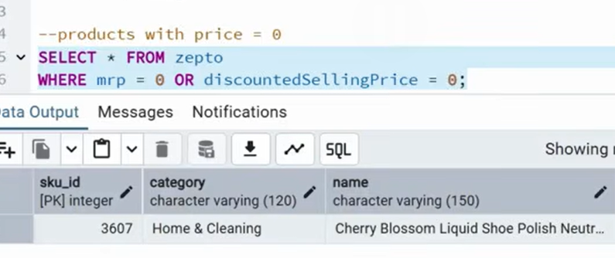
before price :
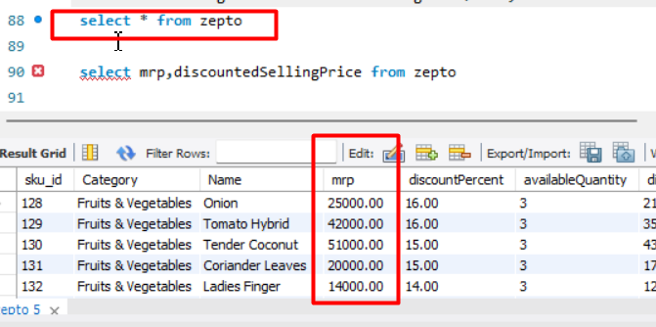
after :
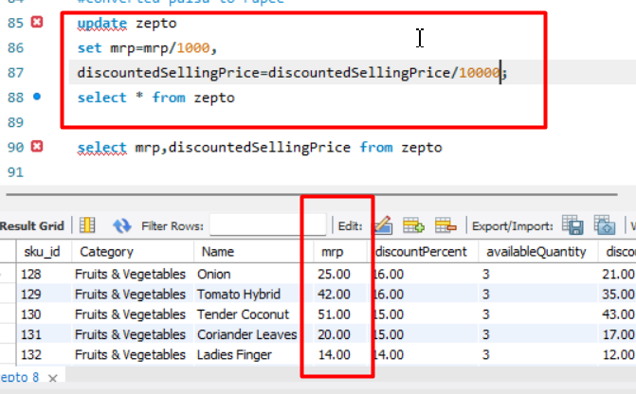
6. SQL Analysis and Business Questions
The project explored the following questions using SQL.
6.1 Top 10 products with the highest discounts
Used ORDER BY discountPercent DESC and LIMIT 10.
Purpose: Identify products offering the highest listed discounts.
6.2 High-MRP products that are out of stock
Filtered products with MRP greater than ₹300 and outOfStock = 1.
Purpose: Identify higher-priced products that are currently unavailable.
6.3 Estimated inventory value by category
Calculated:
SUM(discountedSellingPrice * availableQuantity)
Purpose: Estimate the listed selling-price value of available inventory across product categories.
Note: This is estimated inventory value, not actual sales revenue.
6.4 Products with high MRP and low discounts
Filtered products where MRP was above ₹500 and discount percentage was below 10%.
Purpose: Identify relatively expensive products with smaller listed discounts.
6.5 Categories with the highest average discounts
Used AVG(discountPercent) with category grouping and sorting.
Purpose: Compare the average listed discounts offered across categories.
6.6 Price per gram
Calculated selling price divided by product weight for products weighing at least 100 grams.
Purpose: Compare product prices relative to their weight.
6.7 Product weight classification
Used CASE WHEN to classify products into Low, Medium and Bulk weight groups.
Purpose: Organise products into weight-based categories for further inventory analysis.
6.8 Total inventory weight by category
Calculated:
SUM(availableQuantity * weightGrams)
Purpose: Estimate the total weight of available inventory in each category.
Business insight added by me:
6.9 Which categories have the highest stockout rates?
Calculated total products, out-of-stock products and stockout percentage for each category.
Purpose: Compare stock availability across product categories.
Stockout rate formula:
Out-of-stock products / Total products × 100
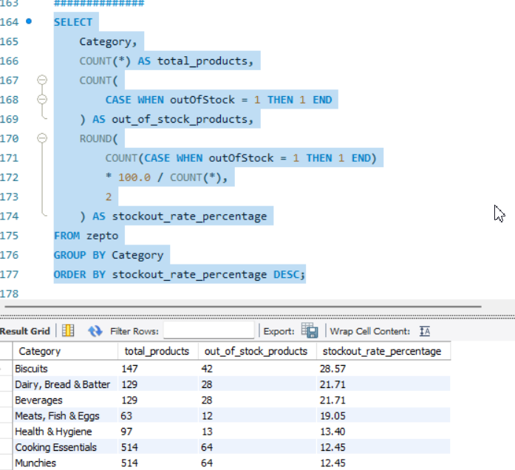6.10 Are higher discounts associated with stock availability?
Grouped products into four discount ranges:
- 0–10%
- 11–20%
- 21–30%
- Above 30%
Calculated total products, out-of-stock products and stockout percentage for each group.
Purpose: Investigate whether stockout rates vary across discount levels.
Actual results:
Discount group | Total products | Out of stock | Stockout rate
0–10% | 2,919 | 399 | 13.67%
11–20% | 579 | 38 | 6.56%
21–30% | 146 | 5 | 3.42%
Above 30% | 87 | 11 | 12.64%
Finding: The stockout rate does not increase consistently with higher discounts. The 21–30% group has the lowest observed stockout rate, while the 0–10% group has the highest.
The dataset does not establish a causal relationship between discounts and stockouts.
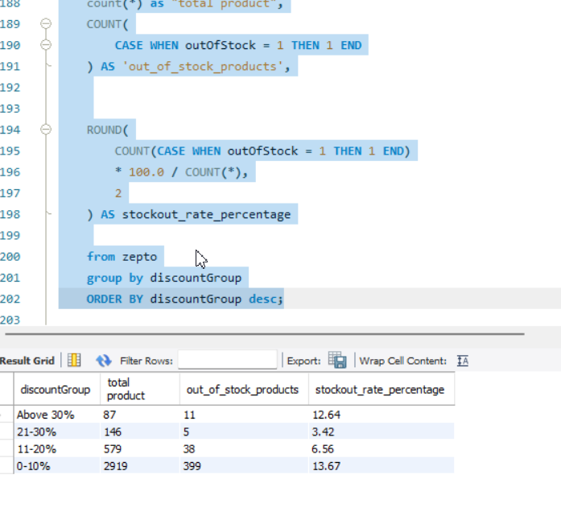6.11 Do listed discounts agree with discounts calculated from prices?
Calculated the implied discount percentage using MRP and discounted selling price.
Formula:
((MRP - Discounted Selling Price) / MRP) × 100
Compared the calculated discount with the listed discount percentage.
Purpose: Investigate possible discrepancies between listed discounts and price-based calculations.
The initial query examined 30 records. A complete dataset-wide comparison is still required before making an overall data-quality conclusion.
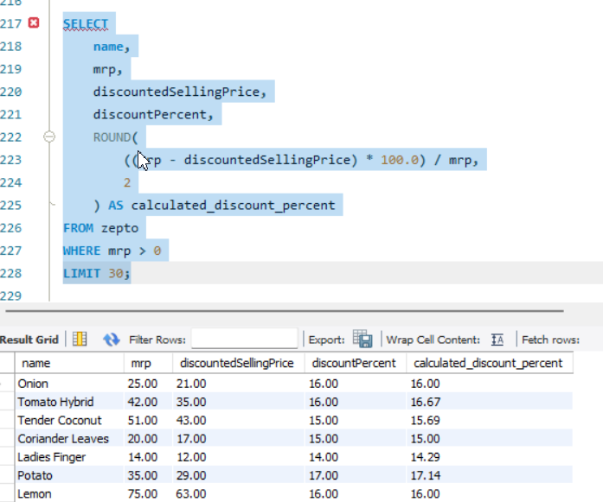7. Key Learning Outcomes
Through this project, I practised:
- Creating databases and tables in MySQL.
- Importing CSV data into a relational database.
- Exploring and checking data quality.
- Cleaning and transforming numerical values.
- Using aggregate functions such as COUNT, SUM and AVG.
- Applying GROUP BY, HAVING and ORDER BY.
- Using CASE WHEN for conditional calculations.
- Calculating percentages and price-based metrics.
- Translating analytical results into understandable findings.
Most importantly, I learned that a SQL result should be interpreted in context rather than treated as an automatic business decision.
8. Project Limitations
- The dataset represents a product and inventory snapshot, not a complete transaction history.
- Actual sales revenue, profit margins and sales velocity cannot be calculated from the available fields.
- Stockout status does not explain why a product is unavailable.
- Discount and stockout patterns indicate associations, not causation.
- The discount consistency analysis initially examined only 30 records.
- Inventory value calculations are estimates based on listed selling prices and available quantities.
9. Conclusion
This project provided practical experience in using SQL for data exploration, cleaning, transformation and product-level analysis.
It also helped me understand the importance of asking analytical questions, checking the reliability of data and communicating findings with appropriate limitations.
Next steps: Complete the full-dataset discount validation, improve project documentation and publish the SQL scripts and presentation in a GitHub repository.

Suggested Gamma presentation structure
Create an 8-slide presentation from this report:
- Project title and objective
- Dataset overview and database structure
- Data exploration and quality checks
- Data cleaning and transformation
- Product pricing and discount analysis
- Inventory and category-level analysis
- Stockout and discount findings
- Key takeaways, limitations and next steps
Use actual result screenshots and charts where appropriate. Keep the slides focused on the analysis rather than filling them with SQL code.

